# Adding Views in the Arizona Transparency Portal

After logging in to the OpenGov portal, click on reports and then click in to the OpenBooks report:

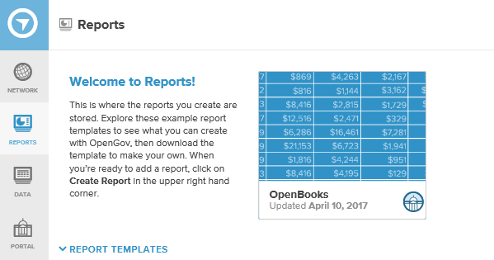

It will bring you up to a screen that looks like this:

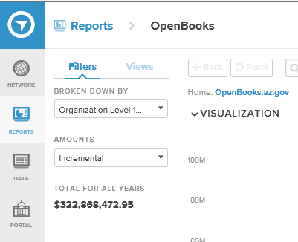

Then you can search for your data until you find what you are looking for, ie. How much does our Police Department Spend? When you are comfortable with the data that you have pulled, click on “+ Save View”

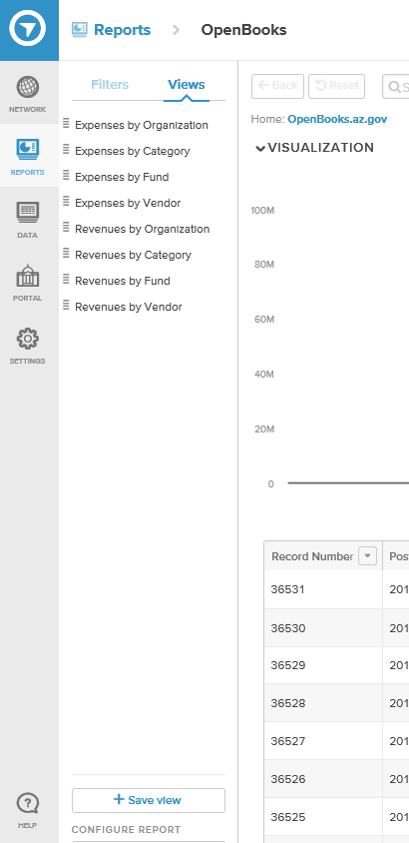

The screen will go blank and this box will appear. Just enter the title for this new view and click “Add Saved View” (Note, it is recommended to keep your title short and less than 70 characters):

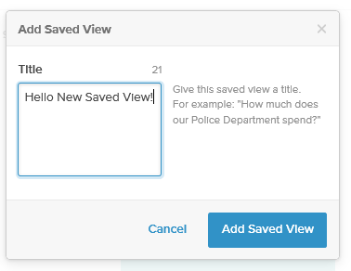

Now your new view will show up on your “Views” tab:

