# Attaching Documents to Site

In order to add documents to your site, login to your opengov.com site:



Then click on the “Portal” tab: 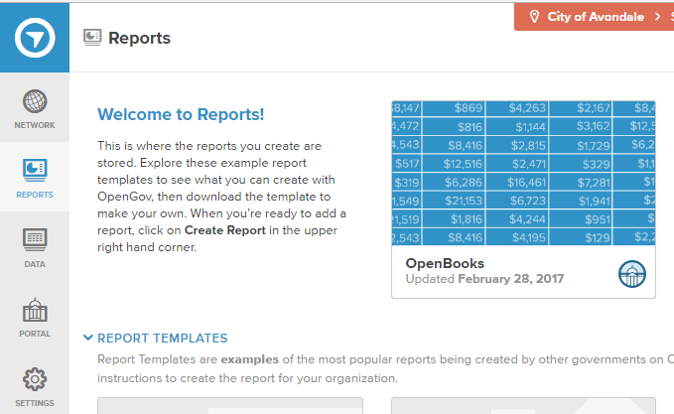

Click on “Supporting Documents” on the left, then “select” on the right: 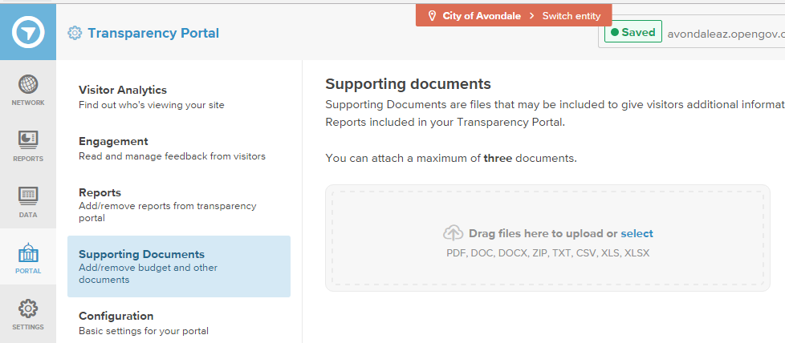

Choose the file you want to attach and click open: 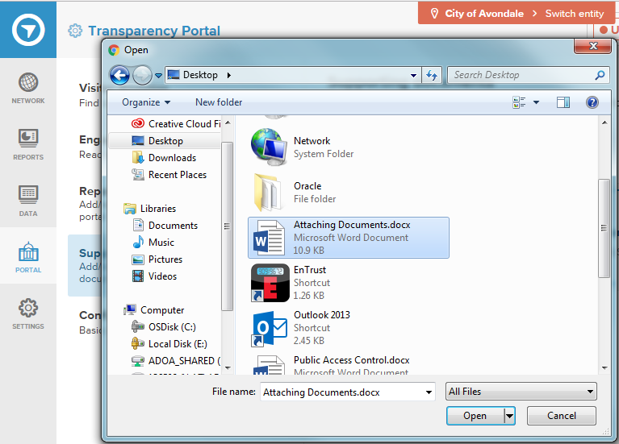

Click Save 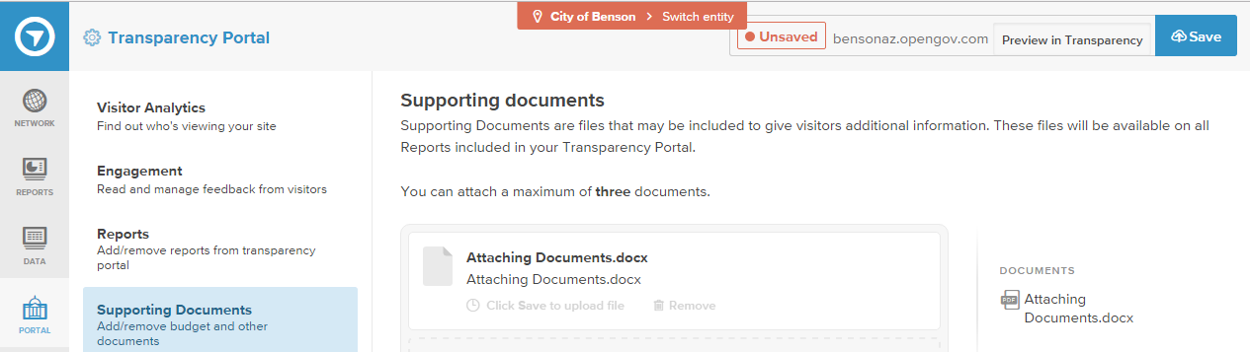

When you view your site you will find the document has been attached:

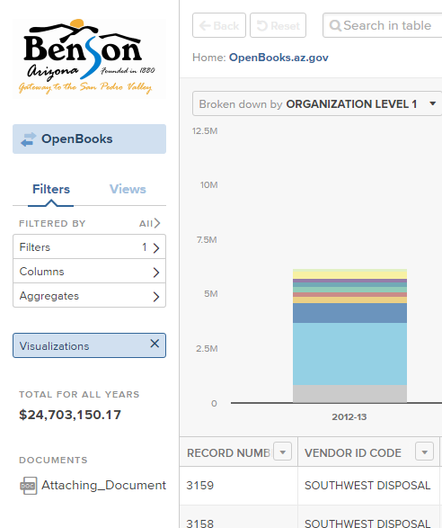

If you no longer want the document attached, follow the above steps but this time click the remove button then the save button: 