# File Conversion Instructions (.txt to .xslx)

Open the .txt file in Excel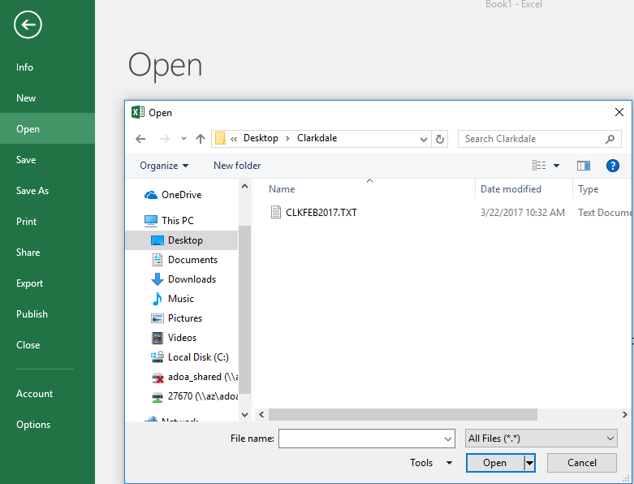

The Text Import Wizard should automatically open. Select Delimited and the “my data has headers”. Then select next.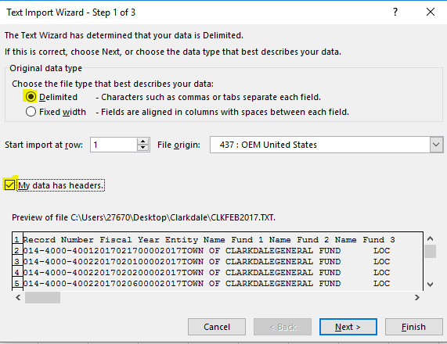

Ensure the Delimiters is set to “Tab” and the Text Qualifier is set to “{none}”. Then select next 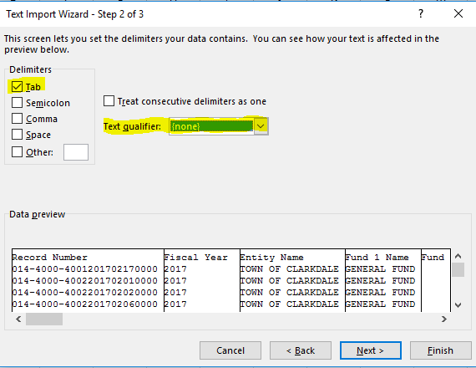

Select “Finish”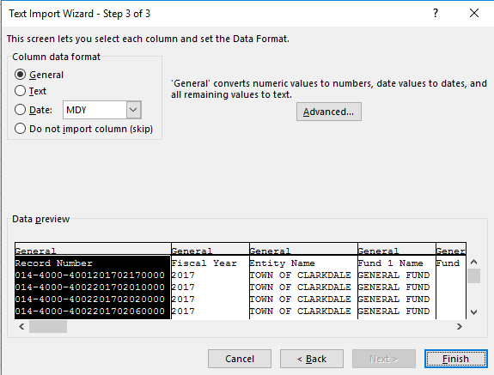

Then in excel select “File”, “Save As” and change the Save As Type to “.xlsx” format. 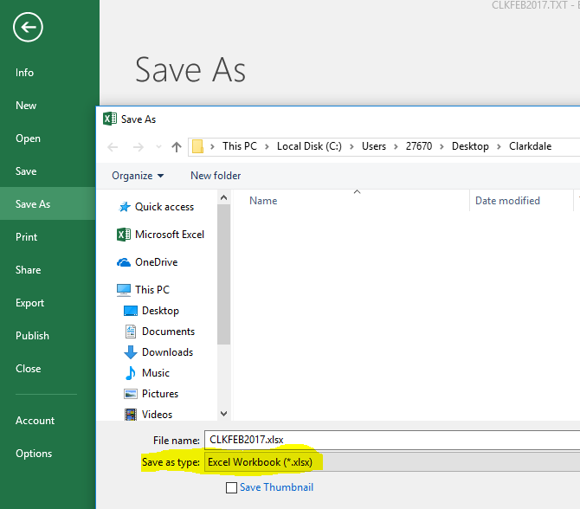

This is the file that can now be uploaded into OpenBooks.