Field Customization

There may be fields that your entity does not use and would prefer them not to be displayed. To remove these unwanted fields please start by logging in to your OpenGov.com site: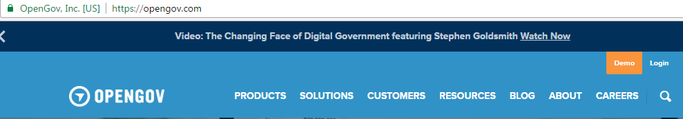

Then click on the “Data” tab, then click on the appropriate Dataset: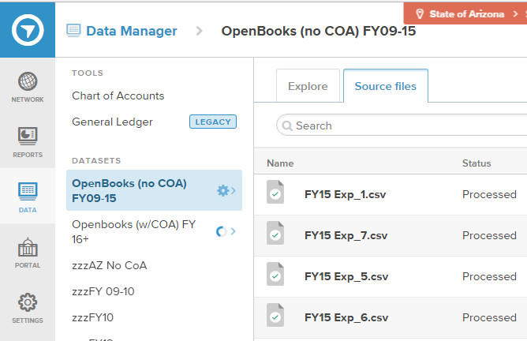

Once your source files populate, click on the Cogwheel and then configure columns: 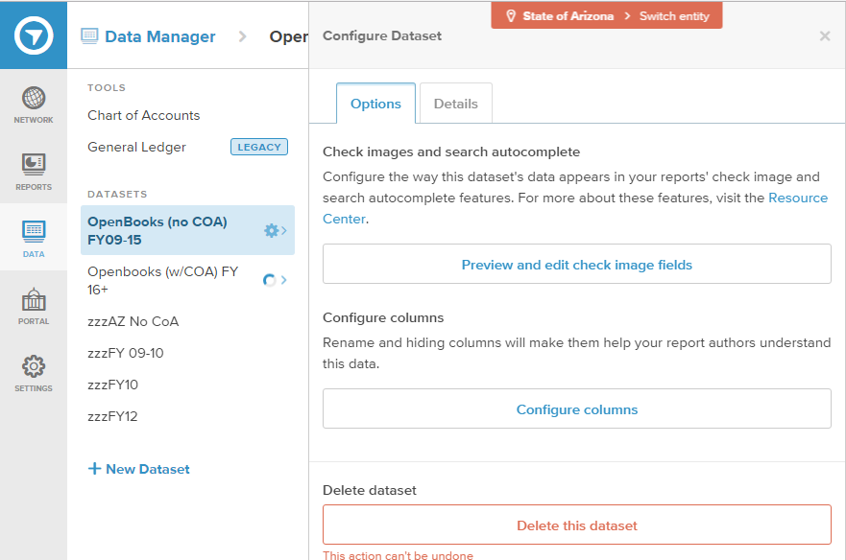

Then uncheck all columns you do not wish to display and click the save button: 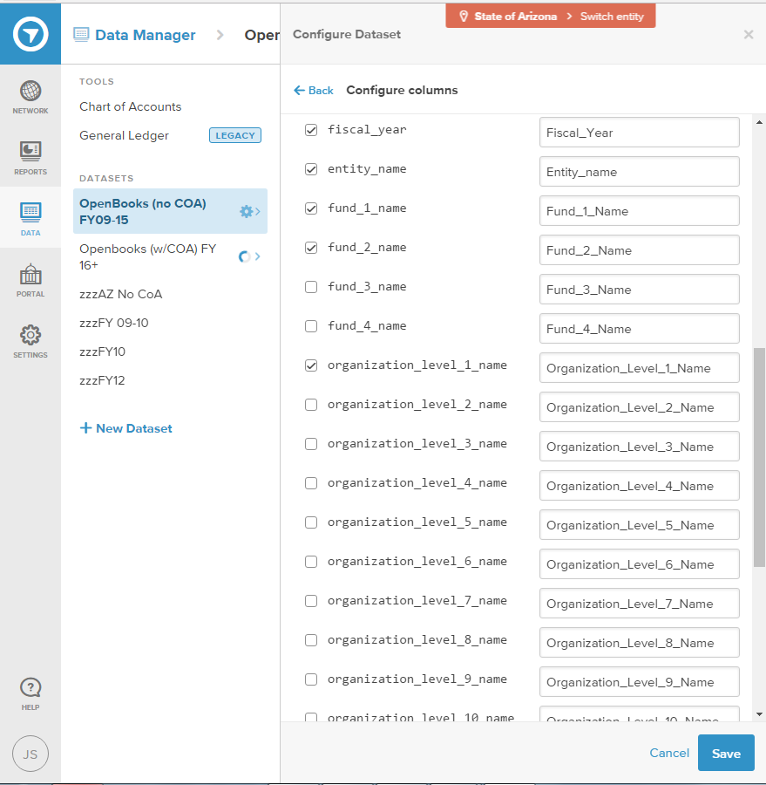

When you return to your reports you will see the fields no longer populate: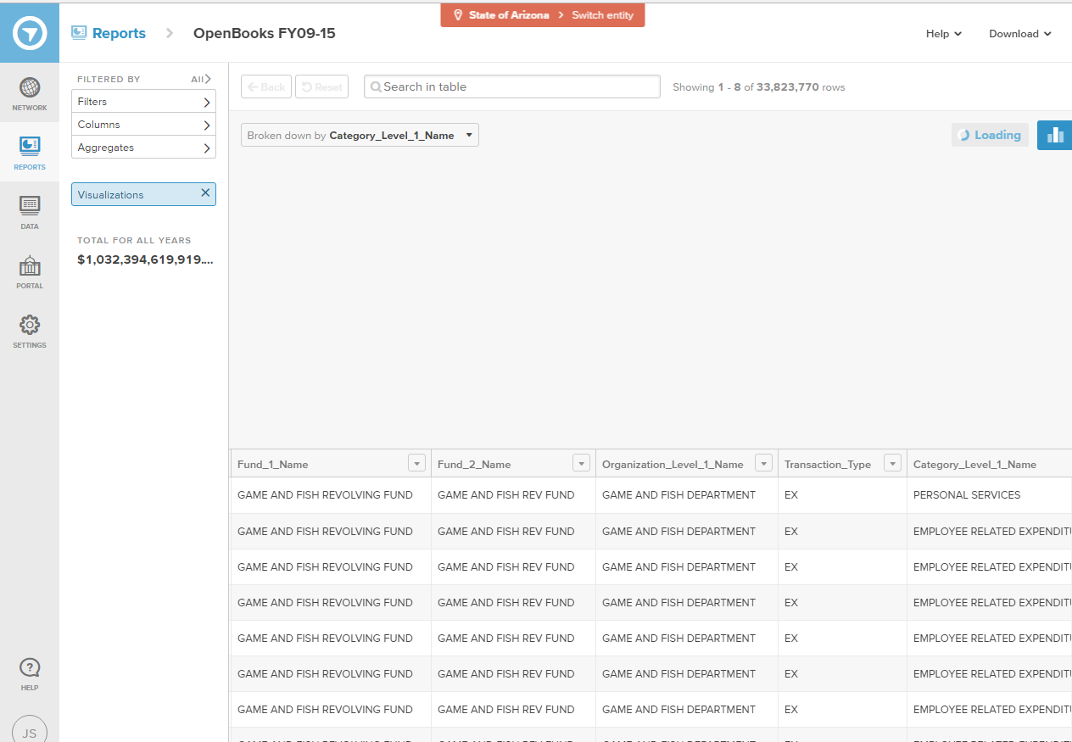

If you wish to add the columns back please refer to the above steps and add the check boxes back and save.