If your entity would prefer to upload data to a test site, or “SandBox”, in order to validate the data before uploading to production, you may contact the OpenBooks team at [openbooks@azdoa.gov](mailto:openbooks@azdoa.gov). The OpenBooks team will work on setting up a SandBox for your entity. Once you have received confirmation that your SandBox is setup you can proceed with the steps below.

In order to upload a test file to the OpenGov.com site, login to your OpenGov.com site:

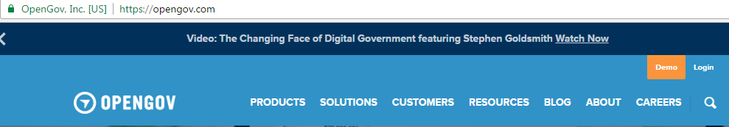

Then click on the “Data” tab on the left side of the screen:

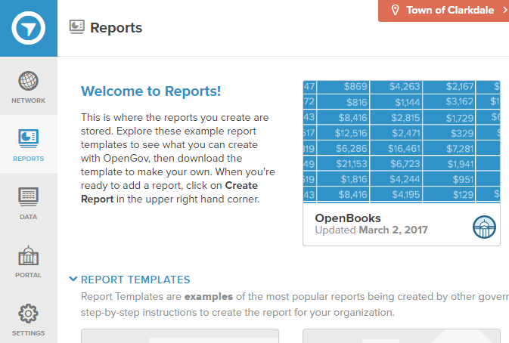

Next, go into your Datasets section and click on “Sandbox for Openbooks”: 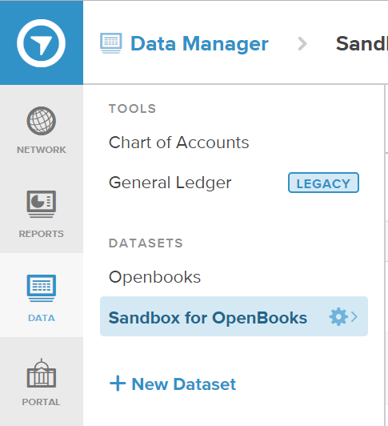

This will bring up all of the files that have been uploaded to this dataset:

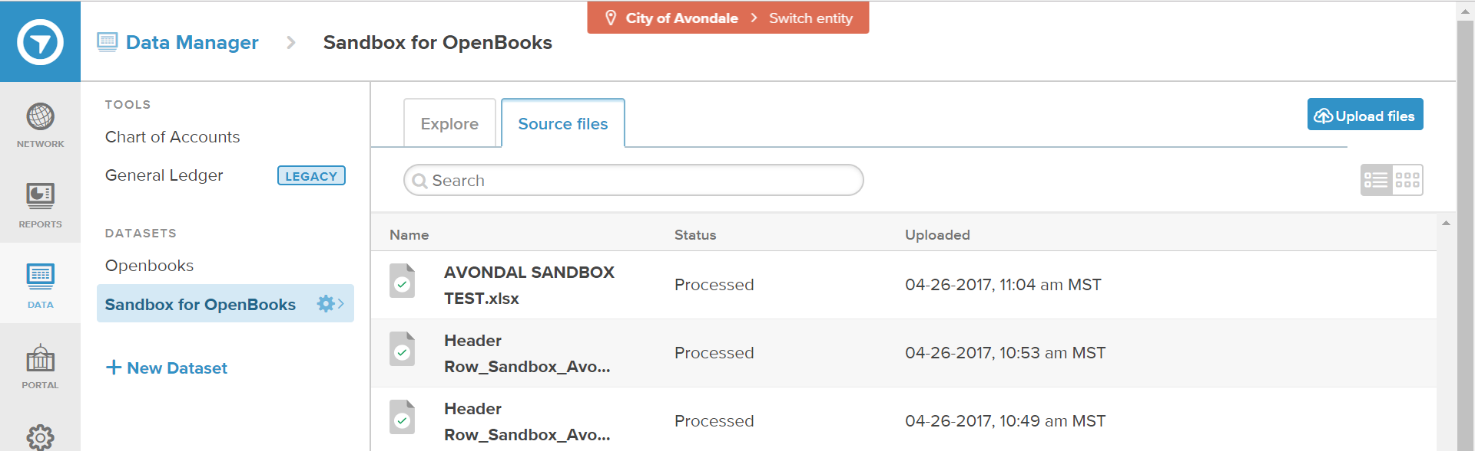

(Note: If this will be your first file you are uploading to the Sandbox you will not see any files listed in this section)

Now you can upload your new file by clicking on the “Upload Files” button on the upper right side of the screen, and simply drag your new files into the upload section:

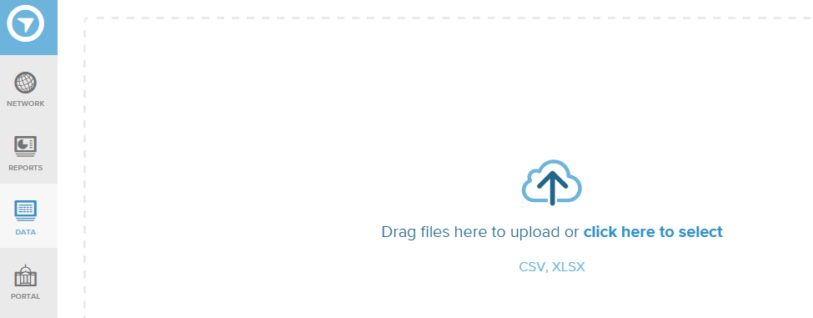

You will get a screen that looks like this while it is uploading: 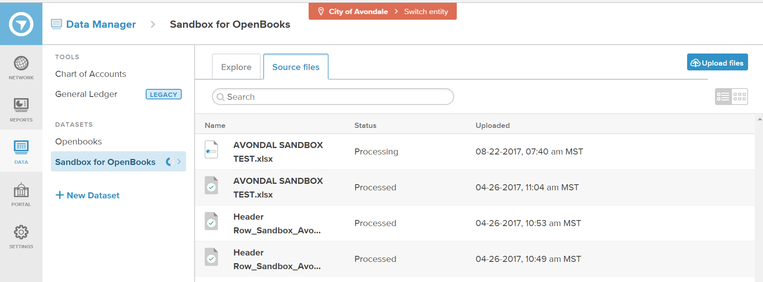

After the file is uploaded properly, it will have a green check and show as “Processed” under the Status column:

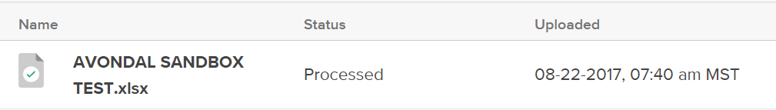

Now you can return to the “Reports” tab on the left side of the screen and reconcile your data:

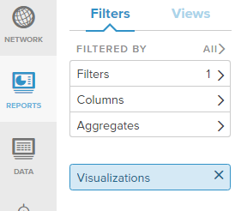

Add in the filters for the data that you uploaded and validate your totals:

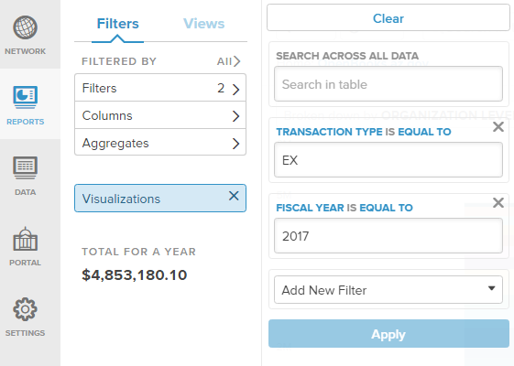

Once you have verified your data is accurate in the SandBox, you can then upload the data to the production site by following the steps below:

First, click on the “Data” tab on the left side of the screen:



Next, go into your Datasets section and click on “Openbooks”:



This will bring up all of the files that have been uploaded to this dataset:

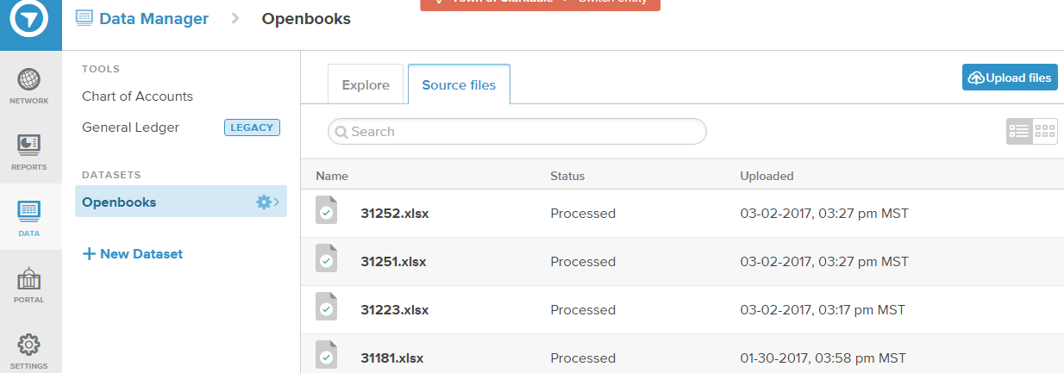

Now you can upload your new file by clicking on the “Upload Files” button on the upper right side of the screen, and simply drag your new files into the upload section:



You will get a screen that looks like this while it is uploading:

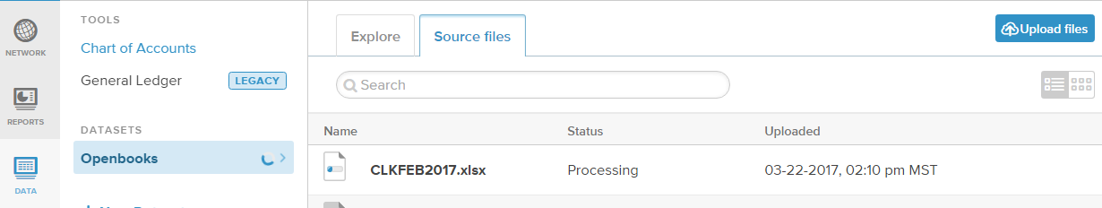

After the file is uploaded properly, it will have a green check and show as “Processed” under the Status column:

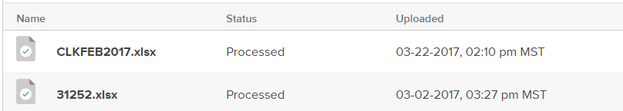

Now you can return to the “Reports” tab on the left side of the screen and reconcile your data:



Add in the filters for the data that you uploaded and validate your totals:



When finished, simply logout to exit.